Network of Organizations of/for the Visually Impaired and the Blind (NOVIB)

Capacity Building Training Organized on Disability and Inclusive Development Issues
For Media Experts and Practitioners
Report on Training Activities

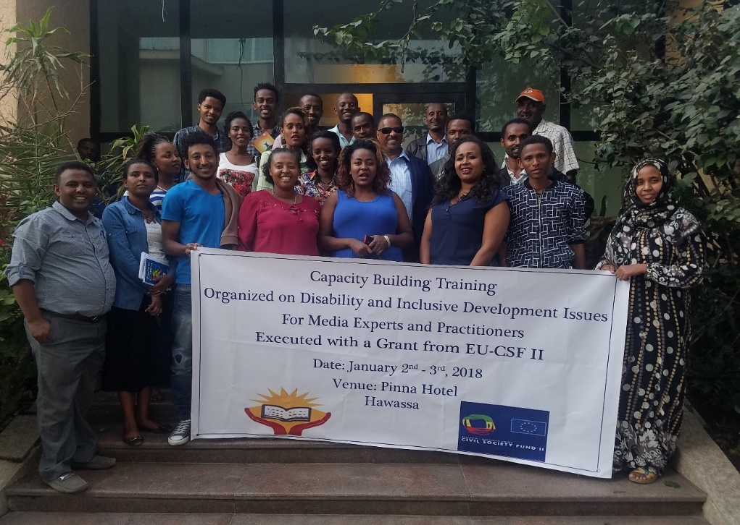

Conducted with the Support of European Union Civil Society Fund II (EU CSF II)

Prepared by: Ephrem Taye, Communications Experta and Media Trainer

January 2018

Contents
BACKGROUND AND PREPARATORY ACTIVITIES 3
Training Objective 4
Summary of Proceedings of the two days: 5
DAY-1 5
Day Two 7
Participants Feedback and Closing 9

BACKGROUND AND PREPARATORY ACTIVITIES
The Training team designed a draft course outline in view of the goal, objectives, activities, roles, and responsibilities of media, Journalists, and communicators. It is also designed as per the ToR and the content was finalized through a discussion with NOVIB team. Participatory methodologies like - group work, interactive discussion, experience sharing, case study, and question-answer were followed throughout the training course. The training held on January 3 and 4, 2018 in Hawassa. The main focus of the training was to increase awareness of participants on the issue of disabilities, the rights of persons with disabilities and also inclusive development and social inclusion. Each activity and exercises were designed in order to create a situation where the participant can take the issue seriously and to their core daily activities. The overall content of the training revolves around the following topics:
The major contents of the training course include
• What is a disability?
• Disability vs Impairments
• Overview of International and National Legal Frameworks for the rights of Persons with
disabilities
• Exclusion vs Inclusion
• Stereotype, prejudice, and discrimination and how the media can reinforce and
discourage them
• What is right based approach
• Exploring Social model and social inclusion
• Barriers to inclusion
• The role of media in a society
• How the media can help in covering the issue of disabilities
• Story Ideas to report about
• Developing action plan

There were 23 trainees to take part in each training session. Regarding trainees’ profile, five of them are practicing Journalists, the others are PR and communicators in different government offices. Out the 23 trainees, nine of them were ladies. As we learned from their discussion, all participants that are coming from the government offices are engaged in their respective organizations’ PR work and responsible for the publications that are going out for the internal and external audiences.

Training facilitation from NOVIB viewpoint was good. We delivered the training according to our pre-planned scheduled although we noticed a shortage of time on some session to discuss properly, particularly we could not manage to discuss and give feedback on the action plan developed by the participants to take the issues of disabilities and inclusion forward. Totally, the facilitation was good.
All the presentations including the practical session worked well. Most of the trainees were so eager to learn and contributed to the liveliness of sessions. Due to the late arrival of the trainees and some technical problems with the projector the first-day session had to start a bit late. Other than that, the training went well.

The trainer would like to appreciate and thank Ato Getu for his presence and eloquent elaboration on the issues and questions arise on the course of the two days.

Training Objective
The main objective of this media workshop is to disseminate the knowledge and create a better understanding and a positive attitude on the issues of disabilities and also towards persons with disabilities among journalists from different media outlets through discussion and dialogue with the experts in the sector and also encourage the journalist to cover the issues of disabilities. And the specific objectives are to:

- Make sure that training participants are sufficiently informed on the concepts and perspectives of disability in light of current researched facts and evidence, and the essence and significance of inclusive development practice;
- Equip trainees with the necessary set of skills and methods that they can apply in a continuing effort to refresh and update themselves on disability and inclusion issues as a regular part of their media practice;
- Enable trainees to understand, appreciate and commit themselves to their role and responsibilities towards the creation of an inclusive society for persons with disabilities in light of professional ethics, as well as relevant global and national policy and legal frameworks;
- Enhance the capacity of participants in respect to the cascading/transfer of the knowledge and skills acquired to colleagues and contributing to the promotion of inclusive media practice so that it becomes part of the institutional systems in which they operate.

Summary of Proceedings of the two days:

DAY-1
In opening Session Ato Getu Mulatu The Director of NOVIB gave an opening remark indicating the aim of the training. He welcomed them all and encouraged all the participants to be open enough to others and be active participants in the discussions and in the course of the two days. After the brief opening session, the participants got introduced with each other by name, designation, place of work and organization through bole throwing game which facilitated communication and movement across the room and amongst organizations in the innovative ice-breaking session. They also introduced each other one by one. The trainer thanked all the participants for nice participation and introduction to each other’s’ background, level of commitment and service/training experience.

Participants gave their expectation by writing on sticky notes; the trainer collected the views, expectations, and ideas of participants and summarizes the ideas at the outset of every session for expected outcomes. After discussion of the expectation, the facilitator shared course objective through multi-media presentation and explain one by one. Then responded accordingly to questions of the participants. Next to that with the guidance of the trainer, the participants formulated the norms of training in a participatory manner.
After the introduction and their expectation had discussed well the trainer asked the participant to pair up and throw the first thing that comes to their mind when they hear the word ‘Disability’ and tell the plenary the result of their discussion.
"A person who needs support," "A person who is dependent on others,” A person who cannot perform certain tasks and duties because of her/his disabilities,” were the ideas most mentioned and discussed. This exercises' intention was to assess their perception and attitude towards persons with disabilities and the issue of disabilities.
After discussing the universally accepted definition of disability, the difference between disabilities and impairments, and also providing facts and figures about disabilities, the training proceeded to the elaborated discussion on the UNCRPD and other international and national legal frameworks on the right of persons with disabilities.
The participants guided through the CRPD and review some of the key and pertinent articles and sub-articles of the convention. Starting from the constitution to the national plan of action of persons with disabilities, participants had a chance to overview and discuss the national legal frameworks formulated inline of the CRPD in order to facilitate the inclusion of persons with disabilities. Just before lunch break the invited guest speakers who are people with disabilities, (one blind woman and two people with physical disabilities), have joined the group and share their experiences and challenges while they are going through their daily lives. It was a lively discussion and a session that gives an insight for the participants of the daily struggles a person with disabilities can face.
While going to lunch and throughout the lunchtime four volunteered participants have been blindfolded, and the afternoon session started by listening to their experiences and impressions. both the four volunteers and their aides have said that the experience gave them a deeper sense and understanding of the situations people with disabilities are living in and their challenges, particularly the issue of accessibility.
In the proceeding sessions, the issues of discrimination and exclusion against people with disabilities, what social inclusion is and what are the barriers to inclusion. The participants asked to form four groups to discuss the barriers people with disabilities are facing. for each group, a category of disability was assigned so that they can discuss in detail about the barriers people with that specific disability have to overcome to be able to participate in the social life they are part of.
The group that discussed the barriers of people with hearing impairments have identified the limited format information is being shared as the main barrier. Limited knowledge and skill of sign language among the community and even the families also mentioned as another communication barrier people with hearing impairment are facing.
The barriers mentioned by the group that was discussing the issue of intellectual disabilities were mainly evolved around attitudinal barriers that are results of the wrong and distorted perceptions the community has towards people with intellectual disabilities.
The group that discussed the physical disabilities and the barriers faced by people with physical disabilities mentioned economical, physical, and also attitudinal barriers. This group has also tried to highlight the link between economical barriers and that of attitudinal barriers. In their presentation, they said people with physical disabilities often denied access to finance due to the perception of people in the microfinance and credit associations. These people often do not have a confidence that people with physical disabilities could not be successful in any business and managed to pay back the loan and reject their request for finance.
The group that was discussing visual impairment, has identified physical, and attitudinal barriers and touched upon the inaccessibility of information for people with visual impairment and the blind.
After the group presentation facilitator provides the common agreed types of barriers which are attitudinal, Institutional, and physical. Ato Getu adds to this point and barriers can be further classified per disabilities because the barriers people with disabilities are facing are different according to their disabilities and the need that arises from their specific type of disabilities. It was also emphasized that identifying barriers is helpful to break down them and ensure the participation and inclusion of people with disabilities.
Then the participant again went back to their respective groups and discuss stereotypes, prejudice, and discrimination towards people with disabilities and how the media can reinforce or discouraged it.
The participants have identified the stereotypes hidden in the usage of the language and proverbs and the prejudice and discrimination against people with disabilities in the social interaction. Then they capitalized on the significant role media can play by focusing on the abilities of people with disabilities, restraining from using those words, languages, and proverbs that are loaded with negative meaning on people with disabilities and about disability. It is also the media's role to promote a positive image of persons with disabilities as per the participants. This is an exercise that creates a conducive situation for the second-day sessions which are mostly dealing with the media's role in promoting the issue of disabilities, people with disabilities and inclusion.

Day Two
Day two kicked off by recapping the topics of the previous day. Then proceeded to discuss what the media role is in any given society. Most of all participants have a very good understanding that the media role is to educate, entertain, and inform the general public. But it is also expected that the media can serve as being the voice for the voiceless. Hence since people with disabilities have been the marginalized and ignored members of society the media has responsibilities to cover people with disabilities and their issues in a proper manner. The facilitator emphasized on the social responsibility of the media. As an institution in any given community media has corporate social responsibilities. Therefore, it has to fulfill these responsibilities by consistently covering social issues such as disabilities and making sure these issues are on the public agenda. It is also important to make sure the issues of disabilities are covered for the sake of coverage instead ensuring the highest ethical standards is maintained.
On the course of the day, it was discussed that the media can help to promote awareness, promote policies, products, and services. It can also disseminate support services, facts about the improvements in national policies and programs, promote that people with disabilities are present in every community around the globe. It can also promote people with disabilities have the same range of emotions, interests, talents, skills, and behavior as the rest of the population and should be portrayed as having the same complexity of personality and experience as other people of similar age and situation.
The facilitator provided potential story ideas the journalists and communicators can report about such as assessing the accessibility of facilities, infrastructures, and services for people with disabilities. Reporting about organizations in their localities that are providing support and services for people with disabilities, what changes has their local community made to ensure a more accessible environment for people with disabilities, it is also possible for the media to scrutinize the trends in their respective communities and organizations in providing employment opportunities for people with disabilities, etc.
Some key principles were provided while covering the issue of disabilities and people with disabilities. among these key principles, put the person at center stage, not the disability, picture persons with disabilities as part of the general public, meaning the media should make sure equal representation of people with disabilities while covering an issue that concerns the general public such as elections, or while collecting public opinion on current affairs, it is like watching a person in the wheelchair commenting on the election results. Avoid common stereotypes: the superhero and the victims sort of representation of people with disabilities. This is a common pitfall often journalists fall in. Most of the media coverage of successful people with disabilities portrayed them as superhuman or heroes perpetuate the stereotype about the persons with disabilities among the community who are leading an ordinary life. the facilitator has also encouraged the participants to work with journalists with disabilities because it helps the media to elevate people with disabilities to be makers of their own images. showing persons with disabilities as active in society is another key principle because portraying persons with disabilities actively participating in society, interacting with non-disabled people in social and work environments help break down barriers and open lines of communications.
showing disabilities as providers of expertise, services, and assistance is helpful in breaking through the stereotype of presenting persons with disabilities only as recipients of charity, services, and goodwill.
The rest of the second day allocated to let participants develop their own plan of action to take the issue of disabilities, and inclusion forward in their respective organization.
Hence the participants divided into four groups those who have come from government offices and engaged in public relations and communications form two groups because of their large number. Those who come from media house such as Hwassa University Community Radio and Shashemeni FM made one group and those who have come from private firms but also engaged in radio and TV production on the public media outsourced airtime formed another group.

All participants have stated in their action plan that their first step is to share the new information and knowledge they have got for their colleagues and team members in their respective organizations. Those participants who are PR and Communications experts and representing different government offices have also stated their commitment to organizing an internal awareness raising event within their organizations so that other colleagues could also take the issue disability very seriously and to think of persons with disabilities while they are doing their daily routines.
They have also stated that they will make sure the issue of disabilities and people with disabilities are entertained and covered in a proper manner on their organization's publications targets both internal and external audiences.
Participants who have come from Neba Films Production and Bisrat Promotion intered a commitment to produce a 10-minute documentary film on the issue of disabilities. They stated that the details and content of the documentary will be decided after they briefed their colleagues about the training and thoroughly discuss the production and how to go about it. In a rough estimation, it is stated in their action plan that in 3-month time the documentary will be finalized and ready for distribution.
The participants that came from Voice of Hawassa, a community radio of the University of Hawassa, and Shashemeni Fana FM, “Linkin Jam” radio show committed themselves to entertain the issue of disabilities at least once in a week.

Participants Feedback and Closing
The closing session was chaired by Ato Getu Mulatu, Director of ENOVIB. Ato Getu highlighted the successes of the training and encouraged the participants to implement what they have learned during the two days and to share with their colleagues what they have gained as they have promised in their action plan. Ato Getu has also expressed his sincere thanks to participants for their active participation and valuable contribution made in the training sessions.
Participants gave feedback by expressing their positive feelings in respect of the training. Most of the participants have said the activities, games, energizers, and group works were highly relevant and related to the overall objectives of the training and also to that of the specific sessions.
and they gave special thanks to the trainers and ENOVIB. They said that the training would be very helpful for the work they do as journalists, PR and Communications experts. They also said that the duration of the training course is too short some sessions were really rushed through.

