Network of Organizations of/for the Visually Impaired and the Blind (NOVIB)
Workshop Proceedings Report
Date Workshop Conducted: July 25th, 2017;
Time: 8:30AM-03:15PM;
Venue: Azzeman Hotel;
Addis Abeba
Workshop Title: Promoting the Accessibility of the Physical Environment/Infrastructure to Persons with Disabilities.
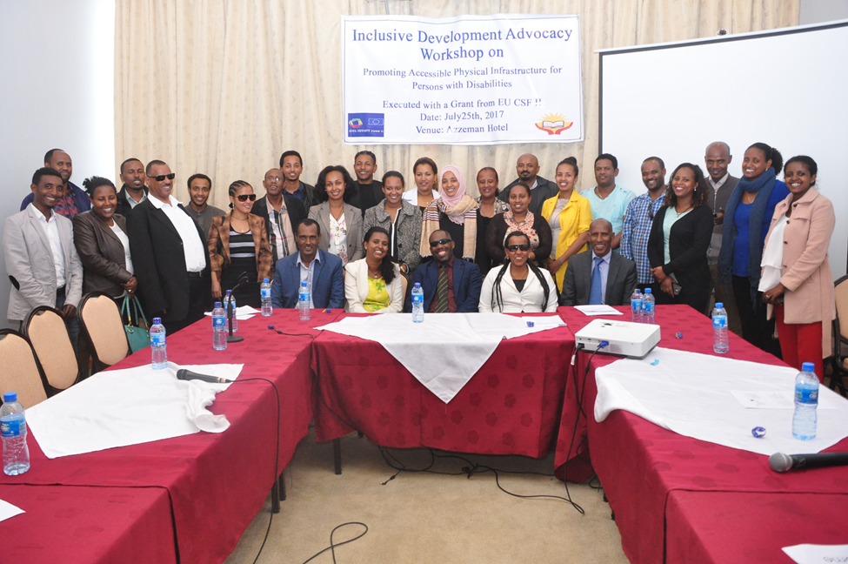
Supported with the Grant of European Union Civil Society Fund (EU CSF) II.

- Opening Session
The Head of NOVIB, Ato Getu Mulatu, welcomed to the event invited guests and participants who represented a broad range of mainly government stakeholder sector organizations at federal and Addis Abeba city administration levels. He made brief remarks about the purpose of the workshop and the importance of the issue from the disability and development perspectives. He laid emphasis on the need to ensure the accessibility of the physical environment for persons with disabilities, if they are to participate meaningfully and on equal basis in all aspects of productive, rewarding and satisfying endeavors.
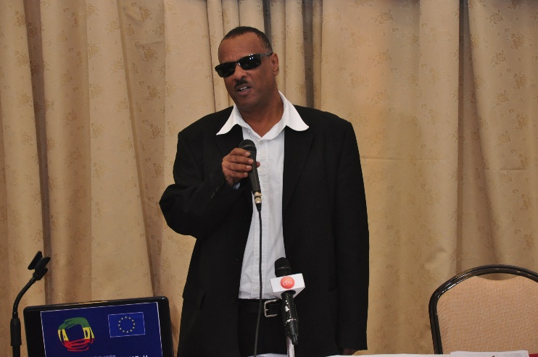
With a view to effectively advocating for the full accessibility of the physical infrastructure to persons with disabilities, the Head of NOVIB indicated that it was vitally important to examine and understand the drawbacks that contributed to the slow progress at policy, legislation, program and practice levels. To this end, he informed the workshop audience that an assessment study was underway that aimed at identifying the strengths and limitations of existing disability sensitive policies and legislations in regards to the building and construction industry, and the extent to which they are translating in to actual practice. The workshop was organized to bring together government and other stakeholders who are major actors in the sector, to deliberate and debate on the preliminary findings of the ongoing assessment study, and contribute inputs based on their practice and experience towards the enrichment of the findings obtained.
Following the welcoming remarks, the workshop participants introduced themselves to each other, telling their names, positions and the organizations they represented. The workshop was attended by a total of 52 invited participants (32 Males, 20 Females), representing 35 key stakeholder organizations at federal and Addis Abeba city administration levels(20 government, and 15 other actors). The presentations and plenary session were moderated by Dr. Abebe Yehualawork, Director of HPD-O.
- Presentations
The first presentation was delivered by W/ro Fikirte Shumet, NOVIB’s Project Coordinator, on the purpose and significance of the workshop. The Project Coordinator informed the workshop participants that the event was organized as an integral sub-component of the larger and more comprehensive project that was being undertaken by NOVIB, in collaboration with ENDAN and six other disabled persons organizations (DPOs). The project is entitled: “Promoting Disability Inclusive Development Practice in Key Socio-economic Sectors”, and is being executed with a grant of EU Civil Society Fund II. In her presentation, the Project Coordinator provided a detailed explanation on the major elements of the project/action including its main objectives, anticipated results, planned activities, geographic areas of operation, co-implementing partners, government and other target groups, as well as the end beneficiaries of the intervention.
Following this, the three core workshop papers were presented in order of the topics stated below:
- The Inclusiveness of Government Policy and Legal Frameworks In Respect to the Accessibility of Physical Infrastructure to Persons with Disabilities;
- By Ato Zekarias Keneaa-Associate Professor, AAU
- College of Law and Governance, School of law
- Inclusive Planning and Accessibility Standards
- By Architect Teshome Ejo-Consulting Architects, Planners and Engineers
- Enforcement Mechanisms for Construction and Building Policies, from Disability Perspectives: The Case of Addis Ababa City Administration
- By Ato Mesfin Bereta

Presentation Paper 1
Topic: The Inclusiveness of Government Policy and Legal Frameworks in Respect to the Accessibility of Physical Infrastructure to Persons with Disabilities.
Presenter: Ato Zekarias Keneaa-Associate Professor.
The first presenter gave a detailed review and analysis of Ethiopian government policy and legislation from the perspective of disability relevance/sensitiveness, by categorizing the provisions and regulations as dating before and after 2010. In doing so, he referred to 2010 as a turning point or milestone year because it marked the ratification of the UN Convention on the Rights of Persons with Disabilities (CRPD), and its domestication into the law of the land.
The presenter noted that the 1960 Civil Code of Ethiopia contained provisions concerning construction. Especially in focus in this connection are Articles 2610-2631; 3019-3040; and 3131-3306. He emphasized, however, that none of the provisions under these Articles dealt with the protection of the rights of persons with disabilities, in connection with the construction of physical infrastructure or other development endeavors. Still, the Civil Code made indirect references and implications that provided for the protection of the rights of persons with disabilities. The principle underlying Article 2069 - Dangerous Activities may be taken into consideration.
The Article states:
Sub-Article 1 “A person who exposes another to abnormal risk, by using or storing explosive or poisonous substances, or by erecting high-tension electric transmission lines, or by modifying the lie of the land, or by engaging in an exceptionally dangerous industrial activity, shall he liable where the danger he has created materialises, thereby causing damage to another.”
Sub-Article 2 “The provision of sub-art. (1) shall apply notwithstanding that the author of the danger is the State or has received an authorization from the public authorities.”
The FDRE Constitution of 1995 in Article 25 provides:
“All persons are equal before the law and are entitled without any discrimination to the equal protection of the law. In this respect, the law shall guarantee to all persons equal and effective protection without discrimination on grounds of race, color, sex, language, religion, political or other opinion, property, birth or other status.”
In Article 41(5), the Constitution provides:
“The State shall, within available means, allocate resources to provide rehabilitation and assistance to the physically and mentally disabled, the aged, and to children who are left without parents or guardian.”
Current Trends Subsequent to UN CRPD
The presenter attached special significance to the ratification of the UN Convention on the Rights of Persons with Disabilities (CRPD) by the Ethiopian government in 2010. He underscored the big changes made since the ratification of CRPD in respect to the protection of the rights of persons with disabilities in the country. The significant improvements made in this regard may be observed in the policies and laws issued since then that embody explicitly disability specific or sensitive provisions.
First and foremost, it is worth noting that CRPD, under Article 4 (General Obligations), states the following:
1 “States Parties undertake to ensure and promote the full realization of all human rights and fundamental freedoms for all persons with disabilities without discrimination of any kind on the basis of disability. To this end, States Parties undertake:
(a)To adopt all appropriate legislative, administrative and other measures for the implementation of the rights recognized in the present Convention;
(b) To take all appropriate measures, including legislation, to modify or abolish existing laws, regulations, customs and practices that constitute discrimination against persons with disabilities.”
In his discussion of the accessibility of the physical environment for persons with disabilities (roads, buildings, transport facilities and other structures/set-ups) Ato Zekarias drew attention to the following government policy, legal and regulatory documents, which he broadly reviewed and critically analyzed.
- Construction Industry Development Policy/2013;
- Ethiopian Building Proclamation no. 624/2009;
- The Council of Ministers Building Regulation no. 243/2011.
Recommended Measures for Further Action towards Institutionalizing Broader Inclusiveness/Accessibility
- More detailed and specific building construction and other infrastructure development policy, legal and regulatory frameworks should be formulated and adopted on the basis of the standards of universal design.
- The federal government and regional states must see to it that the design of all buildings, public or otherwise, is such that accessibility consideration is a mandatory or compulsory requirement, and that the necessary accessibility features are addressed for persons with all types of disabilities.
- Future building designs must be such that they are developed in a manner and form that enables the construction of buildings to be adaptable and adjustable to emerging needs as time goes by.
- Especial attention must be given to the enforcement of existing policies and laws that have been issued to address the accessibility needs of persons with disabilities, in connection with the construction of buildings and other infrastructural facilities.
- The government must adopt all appropriate measures, based on commissioned studies, to abolish customs and practices that constitute discrimination against persons with disabilities, in relation to the accessibility of the physical environment, as per the commitment it has made to the provision under Article 4 of UN CRPD.
- The federal government and regional states should enforce accountability by bringing to justice those who violate laws, regulations and directives issued to protect the rights of persons with disabilities.
- The government must take action to set up a task force that will monitor and track the enforcement of the laws, with a view to ensuring unhindered access to the physical environment for persons with disabilities.
- Clear, audible, and understandable announcements at public places and at transportation facilities are necessary to make sure that the physical environments is accessible to persons with disabilities. On this consideration, concerted efforts must be exerted to ensure the accessibility of transport facilities, parking lots and lavatories, among others, for safe and convenient use by persons with disabilities.

- Signage must be made accessible in easy to read, and easy to understand formats adapted to specific types of disability, including Braille.

- One of the commitments made by the Ethiopian State when it ratified the CRPD is to take both legislative and administrative measures for the implementation of the Convention, but the latter doesn’t seem to have been taken seriously. Hence, federal, regional and local governments must work towards taking appropriate administrative measures to enforce the full and uniform implementation of the Convention, which has been domesticated into the law of Ethiopia by Proclamation No. 676/2010.

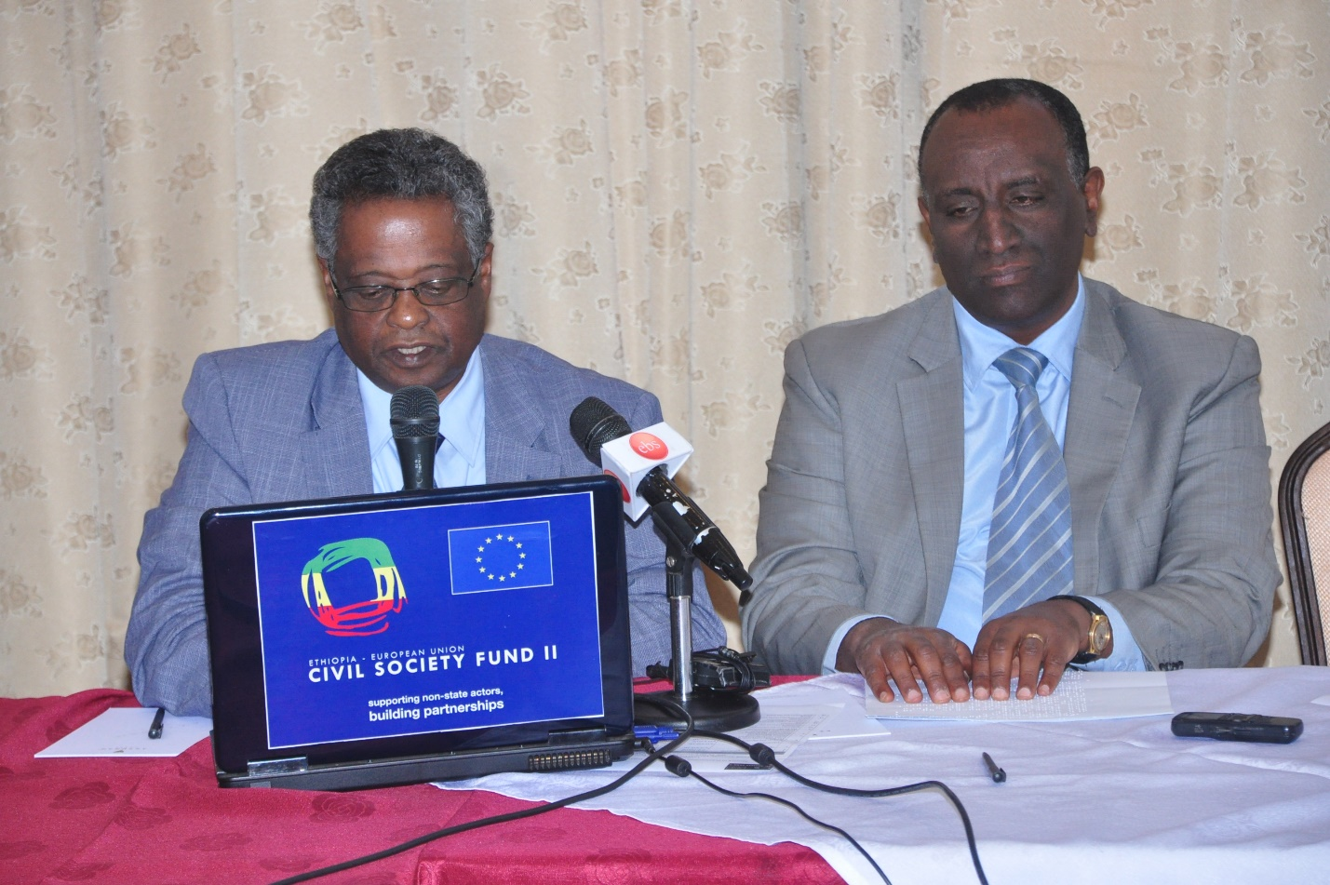

Presentation Paper 2
Topic: Inclusive Planning and Accessibility Standards.
Presenter: Architect Teshome Ejo.
The presenter began by emphasizing that inclusive planning must focus on the fundamental similarities and differences among human beings, and supporting all to achieve full participation and the attainment of self-destiny. He defined accessibility as “ease of reaching opportunities”. Achieving accessibility requires the removal of various sets of obstacles, which can only effectively be done through an integrated approach. Important elements of such an approach are the provision of rehabilitative services, the supply of the necessary assistive/adaptive equipment, the creation/facilitation of access to the physical surrounding and participation, and the process of positive change in attitudes.
Planning must, therefore, take into account the diversity of people and potential obstacles that can hinder their full participation in various daily activities. In light of this, planners need to ask themselves the following basic questions:
- What are the basic activities in which all people are involved on a daily basis?
- What kinds of obstacles, and consequent coping problems, might people face while engaged in these basic activities?
- What – if any – changes are required in current planning practice to ensure that obstacles are not created?
Under accessibility standards, the presenter identified streets/roads, public transport and buildings as the main parts and features of the physical environment for accessibility consideration by designers and planners. The design of streets/roads needs to be human centered, to promote the accessibility of the road infrastructure to all users regardless of their diversity. A human centered and accessible street design is one that is multi-modal, which takes in to account the special needs and circumstances of diverse users such as: persons with disabilities, the elderly, children and newcomers. Examples of accessible street features are ramps, special sidewalks and crosswalks/cross points, sidewalk extensions and medians or refuge islands.
It is not enough that we have only human centred and accessible street/road designs and systems, to ensure barrier free physical environment, the safest possible mobility access, and full and equal participation for persons with disabilities. Transport facilities must likewise be equally accessible. Main features for accessibility consideration in this regard relate to the design of transport vehicles, bus stops and parking lots, among others. The third major aspects/components of the physical environment that also need to be made accessible, in line with the concept and principle of universal design, are all buildings, regardless of who they are owned by, and what services they provide. In connection with this, building designs should take into account the accessibility of entrance ways and steps leading to the buildings, elevators, stairs, handrails, as well as the entire layout/set-up of corridors, floors, rooms, and other facilities, based on the consideration of the whole range of different types of disabilities. To achieve this, inclusive planning and accessibility standards, backed and regulated with specific policy and legal provisions at all stages of the construction process, are essential.
In conclusion, the presenter drew attention to the fact that, changes in the accessibility of the physical environment, could hardly happen without bringing about positive changes in the mind sets and attitudes of people and the society at large. Therefore, a barrier free and inclusive physical environment in all three sectors: the road infrastructure, transport facilities and buildings, cannot be imagined and realized, in isolation from the transformation towards accessibility sensitive and conscious operational and regulatory systems.
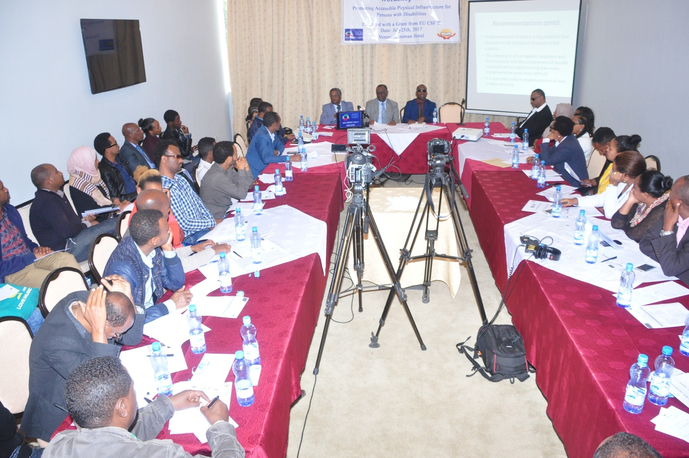

Presentation Paper 3
Topic: Enforcement Mechanisms for Construction and Building Policies from the Disability Perspective The Case of Addis Ababa City Administration.
Presenter: Ato Mesfin Bereta
The presentation focused on the four fundamental questions that need to be addressed by the concerned bodies of Addis Abeba City Administration. These are:
1. What enforcement mechanisms are in place for construction and building policies from the disability perspective?
2. What is the present implementation status of construction and building policies in Addis Ababa City Administration?
3. What are the challenges in the implementation of these policies and their impacts on ensuring the socio-economic, political and cultural rights of persons with disabilities?
4. What measures should be taken to create an accessible physical environment for persons with disabilities living in the city?
After reviewing the implementation status of the construction and building policies in Addis Abeba City Administration, the presenter identified the following gaps that need to be addressed towards the full enforcement of the regulatory instruments.
- The policy instruments fail to define disability and accessibility in clear and specific terms. The instruments are also lacking in the mechanisms of enforcement such as the provision of incentives for those who comply, and the imposition of penalties on others who violate the regulations.
- It was observed that the implementation of construction and building policies particularly from the disability and accessibility perspectives is currently at a very low level.
- As a result, the disability specific principles and goals of the policies have been compromised.
- The failure to effectively implement the policies results from lack of awareness about the instruments, inadequate technical knowledge of translating accessibility standards in to practice, limited understanding of disability as a conceptual and operational term, the wrong attitudes of construction developers towards the issue, lack of coordination between the various actors in the construction and building sector, and human and material resource constraints.
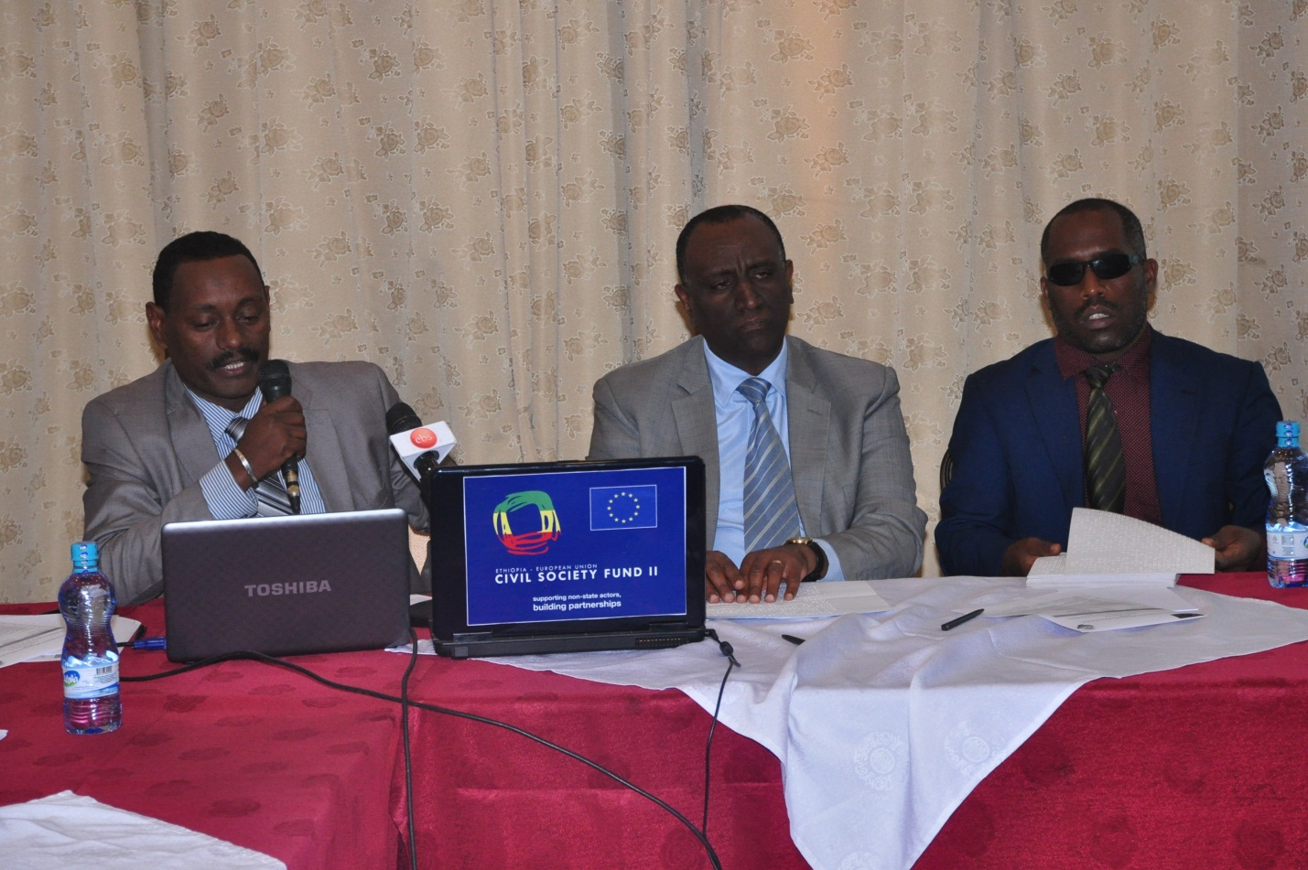

Recommended Action Measures
- Extensive awareness raising campaigns will need to be undertaken on disability and accessibility issues for all government and other actors and stakeholders in the construction and building industry.
- Policy amendment is required in order for the instruments to be inclusive of all types of disability, define the terms of disability and accessibility based on current and accurate understanding of the issues, and underscore their enforcement as mandatory rather than conditional.
- A comprehensive policy and legal framework is essential on disability and accessibility so that the concerned bodies will clearly understand and appreciate their roles and responsibilities, as well as their accountability in respect to the enforcement of the provisions.
- Capacity building trainings on disability and accessibility issues for construction professionals at all levels are required to enable them practice inclusive design, planning, building and quality assurance/supervision work as part of their regular job exercise.
- A system will need to be put in place to facilitate the coordination of work between different institutions and professionals in the construction and building sector, in the interest of the enforcement of existing policies and regulations.
- Proper monitoring and follow-up process must be consistently undertaken to make sure that the disability and accessibility issues are mainstreamed by all actors in the sector, and the necessary quality assurance measures are adopted in regular and uniform manner.
- The involvement of persons with disabilities through their organizations in the enforcement of policies and regulations is essential as a strategy to support and guarantee effective policy enforcement.
- The enforcement of policies will be effectively managed by informing, educating and motivating the concerned actors and stakeholders, rather than by holding them accountable for non-compliance on all occasions. For this reason, it is appropriate to undertake research on the gaps and challenges in the implementation of policies and regulations, and disseminate the findings through proper channels including the media, to enhance informed decision and action.
Discussion on the Presentations
Following the presentation of the discussion papers, there was a plenary session in which the participants reflected on what was presented, asked questions for further elaboration by the speakers, and shared comments and experiences based on their observations and practice. Particularly three participants were given roles to comment on the presentations as discussants. These were Ato Retta Getachew, Director of ECDD, which is an affiliated entity, Ato Seifu G/michael, Advisor to the State Minster for regulatory affairs at the Ministry of Construction, and Architect Mahider Gebermedhin, producer and presenter of a popular radio program on urban development issues at Sheger FM 102.1.
Ato Retta Getachew shared the experience of his organization in relation to the accessibility audits/institutional mapping of buildings carried out in Addis Abeba. The audits/mapping focused on the identification of public and private buildings, mainly hotels, health facilities and schools, with a view to assessing the degree of their accessibility to persons with disabilities. Ato Seifu G/michael gave an explanation regarding the activities that the Ministry of Construction was undertaking towards institutionalizing inclusive practice at policy and program levels. Architect Mahider G/Medhin highlighted that a strategic intervention should be adopted to involve well-known public figures in the fields of art, athletics and investment to promote inclusiveness and accessibility for specific results. All three discussants agreed that only little was done in the capital to create an accessible physical environment, where there were no barriers to the participation of persons with disabilities in all aspects of life.
In summary, the following major action points were raised and reiterated in the course of the discussion.
- The presentations have identified and drawn attention to the specific gaps and deficiencies in the existing legal and regulatory frameworks dealing with inclusion and accessibility issues from the disability dimension.
- These limitations and inadequacies notwithstanding, the legal and regulatory frameworks providing for inclusion and accessibility for persons with disabilities still have strengths and positive elements. The more serious problem that calls for urgent intervention is that not even these policies and laws, which require revision, are implemented in actual practice.
- A major area of gap noted is the absence of a government structure dedicated to monitor the enforcement of policies and laws issued to provide for the accessibility to persons with disabilities of buildings, roads and transport facilities. Even though MOLSA is considered to be responsible for ensuring the rights of persons with disabilities, its legal mandate, institutional capacity, organizational structure and allocated resource act as limiting factors that undermine its ability to enforce the government’s disability focused policies, laws and regulations.
- When we talk of accessibility, safety is a crucial issue to consider. Safety measures in connection with roads open to public use and the construction of new roads and buildings are essential, and increasingly even more so in present circumstances. Due to lack of safety measures, persons with disabilities are becoming vulnerable to additional impairments, and disability prevalence is rising due to the incidence of accidents that cause people to sustain injuries that result in temporary or permanent impairments. Unfortunately, accountability mechanisms either are not available or are not enforced to hold to account and bring to justice those actors, government or otherwise, who cause such accidents that are likely to result in impairments, among other consequences.
- According to studies, the costs incurred to make one building accessible are estimated only at 2% of the total construction cost of the building. Nevertheless, construction companies and clients are reluctant to make such small expenses in public interest, specially to the benefit of persons with disabilities, emboldened to do so by the knowledge and certainty that there is no mechanism and also the will to enforce the law.
- Finally, one participant made the observation that accessibility was not discussed in the presentations from the point of view of participation by persons with disabilities in sports activities. He noted that gymnasiums, sports fields and youth centers are not accessible to persons with disabilities, which seems to suggest that they have no need for such activities. But Paralympic sports have shown the fact that persons with disabilities are able to participate in this contests, and athletes from Ethiopia have not only successfully participated in these competitions, but have also won medals for their country, maintaining high the name of the nation and being symbols of national pride like other athletes. He concluded by adding that it was regrettable, however, that not enough was done to recognize and reward the contributions of medal winning athletes with disabilities, and give them due credit for their performance and achievements. In addition, not much is done to encourage and support the increased participation of such persons in athletics and other sports, resulting in the wastage of talents and losses to themselves and the society as a whole, the exact costs of which have yet to be estimated and documented.

